Worksheet for FINAL PRACTICAL

Group Number: 6

Student 1 Name: SAHIL THAKUR UID: 22BDA70064

Student 2 Name: SHESHAV SHARMA UID: 22BDA70053

Student 3 Name: BHAVYA JAIN UID: 22BDA70046

Student 4 Name: LUCKY UID: 22BDA70045

Student 5 Name: TUSHAR UID: 22BDA70075

Branch: Computer Science & Engineering Section/Group: 118/B

Semester: 01 Date of Performance: JAN 5,2023

Subject Name: Disruptive Technologies-1 Subject Code: 22 ECH -102

1. Title:

SOCIAL DISTANCING MONITORING

1. **Problem statement:**

The novel generation of the coronavirus disease (COVID-19) were reported in late December 2019 in Wuhan, China. After only a few months, the virus was hit by the global outbreak in 2020. On May 2020 The World Health Organization (WHO) announced the situation as the pandemic .The statistics by WHO on 26 August 2020 confirms 23.8 million infected people in 200 countries.  
The mortality rate of the infectious virus also shows a scar number of 815,000 people. So social distancing was the only solution to stop increasing these cases.

1. **Key Features/Benefits:**

This digital technology enables anonymous and discreet monitoring of spaces to ensure compliance with physical distancing guidelines. It helps identify problem areas to make modifications for the environment with safe work practices to reduce risk.

You can monitor the number of people in an area and measure if they are maintaining minimum advised distance while sitting. standing, or walking

It can also ensure staff safety by

* Spotting people who are standing too close or in a group by setting off an alarm
* Optimum room space utilization
* Notifying when the number of people in an area exceeds safety levels
* Keeping a constant check on the behavior of people, their density, and flow of traffic

1. **Software/ Tools used:**

* visual studio code
* YOLOv3
* OpenCV

**5. Deliverables**

**6. Code:**

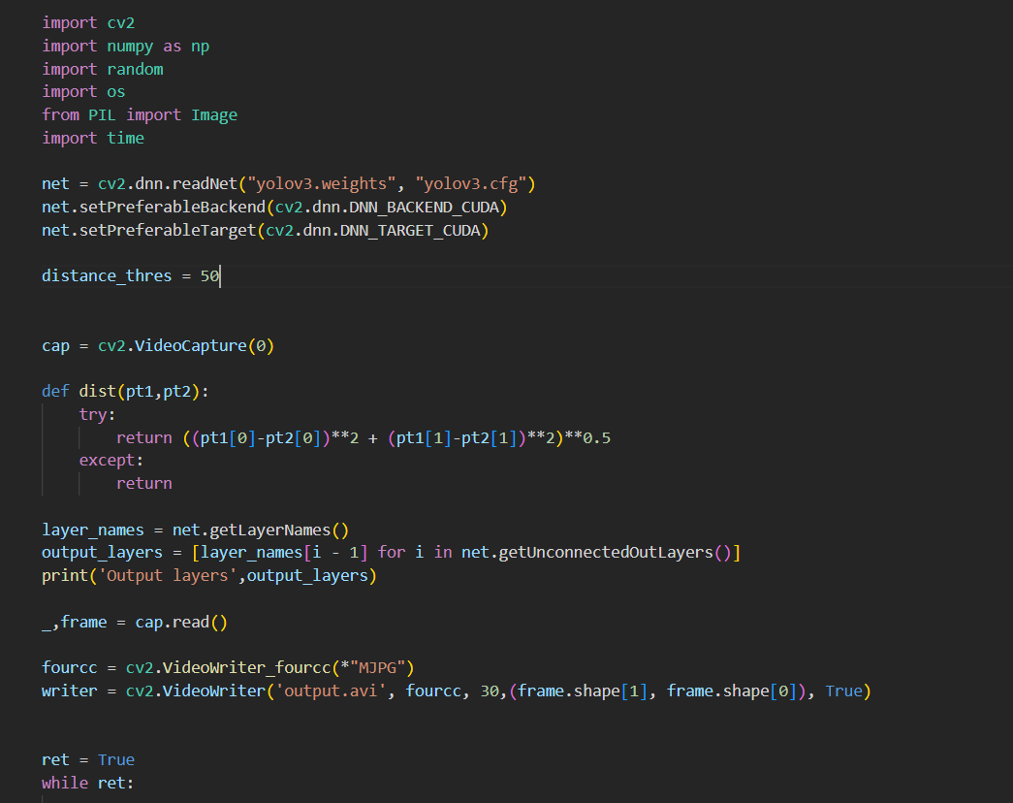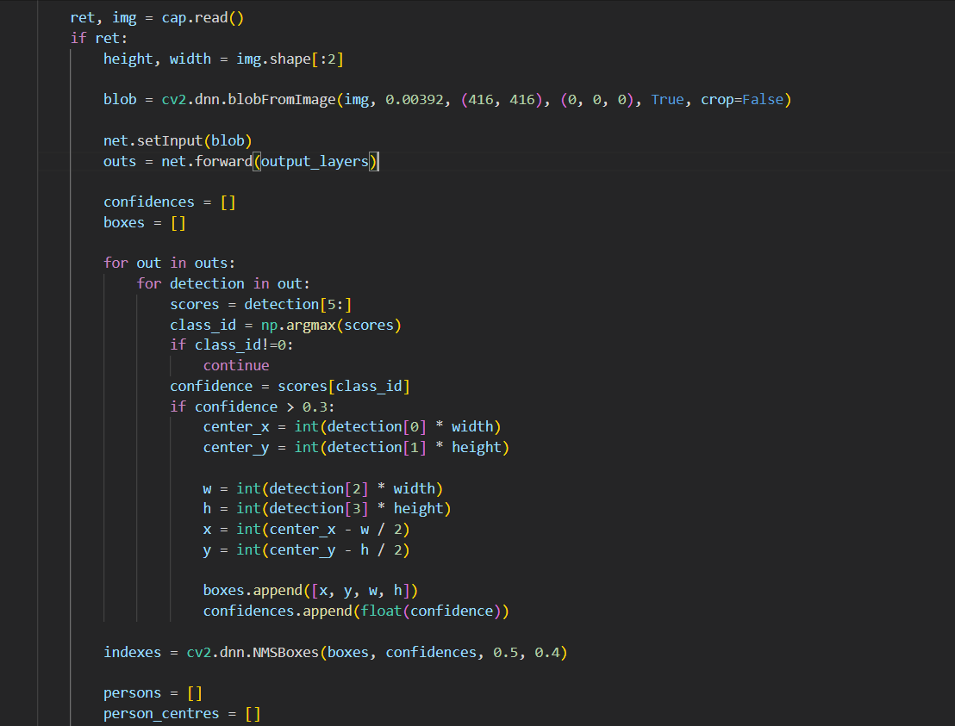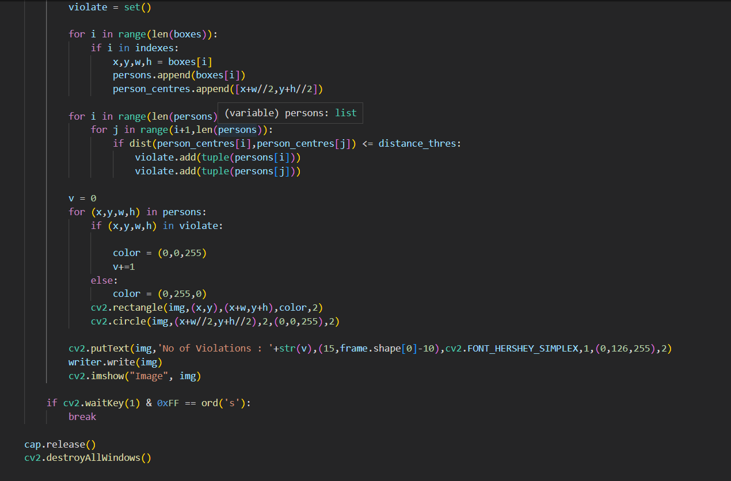

**7. Output:**

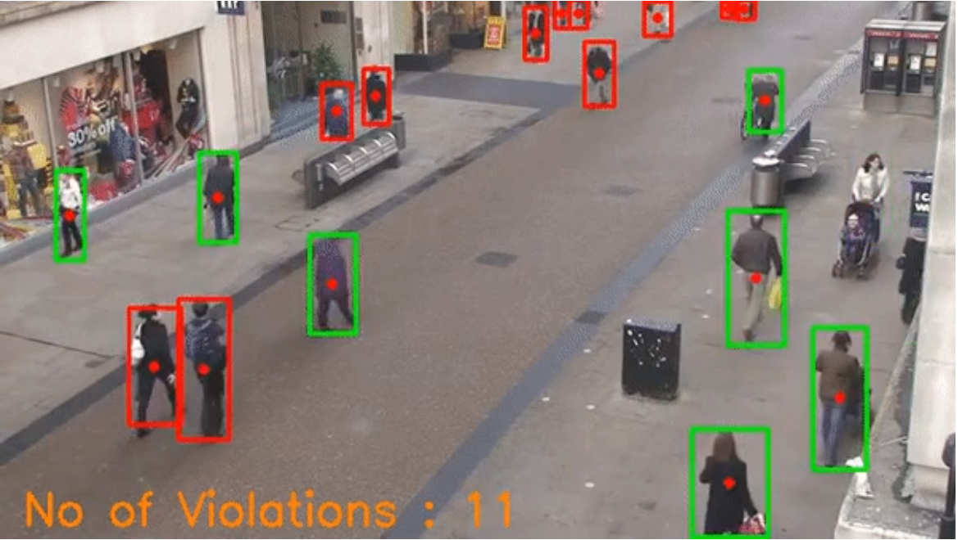

**8. Conclusion and Future Scope:**

We conducted a zone based infection risk assessment and analysis to the benefit of the health authorities and governments. The outcome of this research is applicable for a wider community of researchers not only in computer vision, AI, and health sectors, but also in other industrial applications such as pedestrian detection in driver assistance systems, autonomous vehicles, anomaly behaviour detections, and variety of surveillance security systems.  
The system was able to perform in a variety of challenges including, occlusion, lighting variations, shades, and partial visibility. The proposed method was evaluated using large and comprehensive datasets and proved a major development in terms of accuracy and speed compared to three state-of-the-art techniques. The system performed real-time using a basic hardware and GPU platform.

**9. References:**

**1.** World Health Organization. WHO Corona-viruses Disease Dashboard (August 2020). Available at https: //covid19.who.int/table.

**2.** WHO Director, Generals. Opening remarks at the media briefing on COVID-19 (2020). WHO generals and directors speeches.  
  
**3.** Khandelwal, P. et al. Using computer vision to enhance safety of workforce in manufacturing in a post COVID world. Comput. Vis. Pattern Recognit. DOI: 10.1016/ S0140-6736(20)30185-9 (2020).  
  
**4.** Shi, F. et al. Review of artificial intelligence techniques in imaging data acquisition, segmentation and diagnosis for COVID-19. IEEE reviews biomedical engineering DOI: 10.1109/RBME.2020.2987975 (2020).